|  |  |  |  |  |  |
| --- | --- | --- | --- | --- | --- |
| **MS DMN LTD.**  **123 STUDENT ROAD, OLD UNIVERSITY CAMPUS** | | | | | |
| *Receiver Name:*  *Address:* | | | ***Your order*:**  ***Reference*:**  **Dated:**  **Invoice No.:** | | |
| Invoice | | | | | |
| **S No**. | **Particulars** | **QTY** | | **PIECE PER UNIT (RS.)** | **AMOUNT** **(RS.)** |
|  |  |  | |  |  |
|  |  |  | |  |  |
|  | TOTAL |  | |  |  |
| (Rupees:…………………………………………………………………………………………………………………………….) | | | | | |

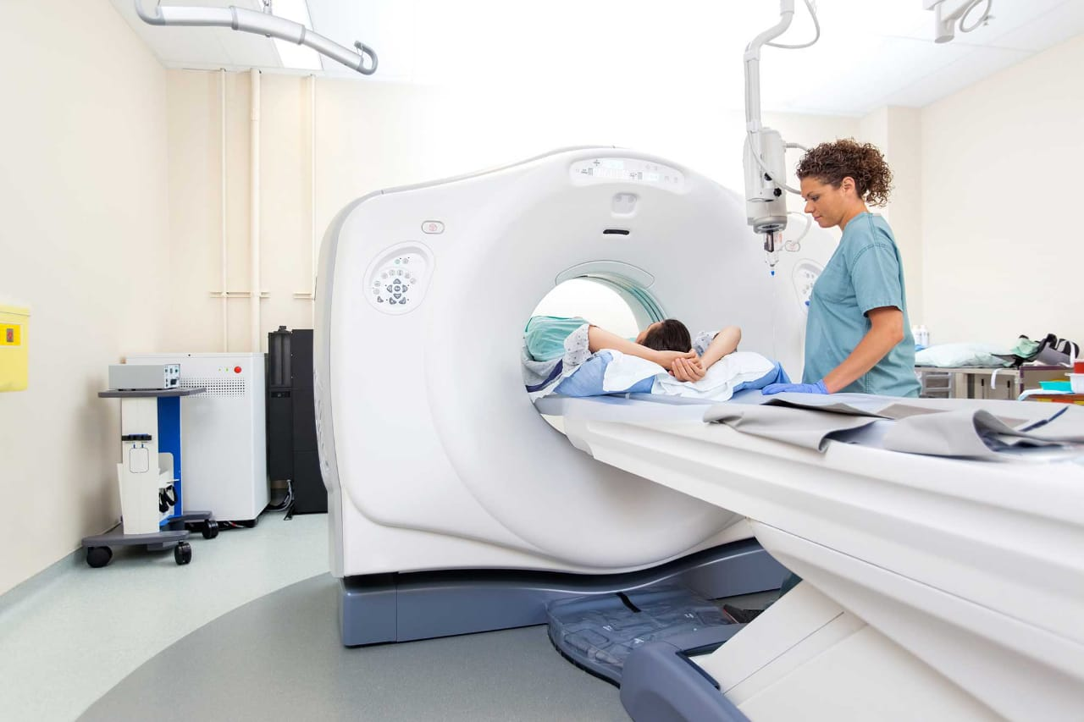**Terms and Conditions:**

1. All disputes within jurisdiction of Delhi Courts
2. Goods once sold shall not be returned
3. All prices are inclusive of sales tax

**For Alpha Ltd.**

(Authorized Signature)