**SWASTHYA: THE VIRTUAL DIETICIAN**

SOFTWARE ENGINEERING PROJECT REPORT

[Submitted in partial fulfillment]

As a part of the curriculum of

B.SC. (H) COMPUTER SCIENCE

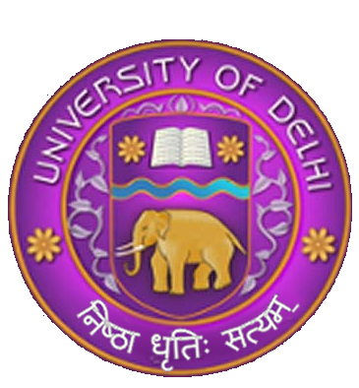

Submitted by:

DIYA GARG (18044570007)

CHAKSHITA GUPTA (18044570015)

MISHIKA RAWAT (18044570032)

**B.Sc. (H) COMPUTER SCIENCE**

**IV SEMESTER**

Mata Sundri College for Women, University of Delhi

Mata Sundri Lane, New Delhi 110002